**MODULE-2**

**Human Resource Management and Organizational Behaviour**

**Human Resource Management:**

* HRM is the study of activities regarding people working in an organization.
* It is a managerial function that tries to match an organization’s needs to the skills and abilities of its employees.
* Definitions of HRM
* Human resources management (HRM) is a management function concerned with hiring, motivating and maintaining people in an organization. It focuses on people in organizations.
* Human resource management is designing management systems to ensure that human talent is used effectively and efficiently to accomplish organizational goals
* HRM is the personnel function which is concerned with procurement, development, compensation, integration and maintenance of the personnel of an organization for the purpose of contributing towards the accomplishments of the organization’s objectives.
* Therefore, personnel management is the planning, organizing, directing, and controlling of the performance of those operative functions (Edward B. Philippo).
* According to the Invancevich and Glueck, “HRM is concerned with the most effective use of people to achieve organizational and individual goals. It is the way of managing people at work, so that they give their best to the organization”

**Functions of HRM:**

* Human Resource Planning
* Design of the Organization and Job
* Selection and Staffing
* Training and Development
* Organizational Development
* Compensation and Benefits
* Employee Assistance
* Union/Labour Relations
* Personnel Research and Information System
* **Human Resource Planning:**
* The objective of HR Planning is to ensure that the organization has the right types of persons at the right time at the right place.
* It prepares human resources inventory with a view to assess present and future needs, availability and possible shortages in human resource.
* There upon, HR Planning forecast demand and supplies and identify sources of selection. HR Planning develops strategies both long-term and short-term, to meet the man-power requirement
* **Design of Organization and Job:**
* This is the task of laying down organization structure, authority, relationship and responsibilities.
* This will also mean definition of work contents for each position in the organization. This is done by “job description”.
* Another important step is “Job specification”. Job specification identifies the attributes of persons who will be most suitable for each job which is defined by job description.
* **Selection and Staffing:**
* This is the process of recruitment and selection of staff.
* This involves matching people and their expectations with which the job specifications and career path available within the organization.
* **Training and Development:**
* This involves an organized attempt to find out training needs of the individuals to meet the knowledge and skill which is needed not only to perform current job but also to fulfil the future needs of the organization
* **Organizational Development:**
* This is an important aspect whereby “Synergetic effect” is generated in an organization i.e. healthy interpersonal and inter-group relationship within the organization.
* **Compensation and Benefits:**
* This is the area of wages and salaries administration where wages and compensations are fixed scientifically to meet fairness and equity criteria.
* Labour welfare measures are involved which include benefits and services.
* **Employee Assistance:**
* Each employee is unique in character, personality, expectation and temperament.
* By and large each one of them faces problems everyday. Some are personal some are official. In their case he or she remains worried. Such worries must be removed to make him or her more productive and happy.
* **Union-Labour Relations:**
* Healthy Industrial and Labour relations are very important for enhancing peace and productivity in an organization.

**Recruitment:**

* According to Edwin B. Flippo, “Recruitment is the process of searching for prospective employees and stimulating them to apply for jobs in the organisation.”
* In the words of Dale Yoder, “ Recruiting is a process to discover the sources of manpower to meet the requirements of the staffing schedule and to employ effective measures for attracting that manpower in adequate numbers to facilitate effective selection of an efficient working force.”
* Thus, recruitment process is concerned with the identification of possible sources of human resource supply and tapping those sources.

**Process of Recruitment:**

* Recruitment process begins when the personnel department receives requisitions for recruitment from any department of the company, The personnel requisitions contain details about the position to be filled, number of persons to be recruited, the duties to be performed, qualifications expected from the candidates, terms and conditions of employment and the time by which the persons should be available for appointment etc.
* Locating and developing the sources of required number and type of employees.
* Identifying the prospective employees with required characteristics.
* Developing the techniques to attract the desired candidates. The goodwill of an organisation in the market may be one technique. The publicity about the company being a good employer may also help in stimulating candidates to apply. There may be others of attractive salaries, proper facilities for development etc.
* Evaluating the effectiveness of recruitment process

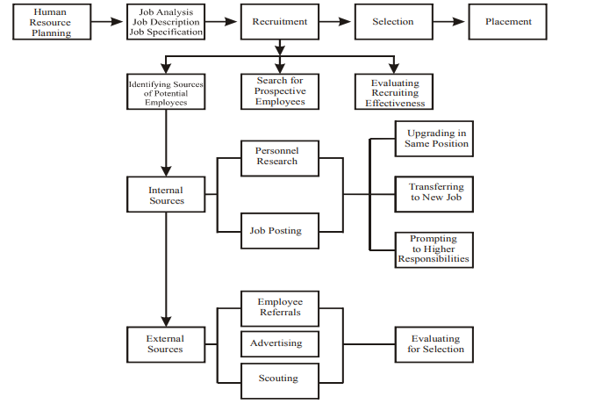

**Selection:**

* Human resource selection is the process of choosing qualified individuals who are available to fill positions in an organization.
* Selection is the process of choosing people by obtaining and assessing information about the applicants with a view to matching these with the job requirements.
* It involves a careful screening and testing of candidates who have put in their applications for any job in the enterprise.
* It is the process of choosing the most suitable persons out of all the applicants. The purpose of selection is to pick up the right person for every job.
* “Selection is the process of differentiating between applicants in order to identify (and hire) those with a greater likelihood of success in a job”- Thomas Stone
* “The selection procedure is the system of functions and devices adopted in a given company for the purpose of ascertaining whether or not candidates possess the qualifications called for by a specific job or for progression through a series of jobs.”- Michael Jucius

**Selection Process:**

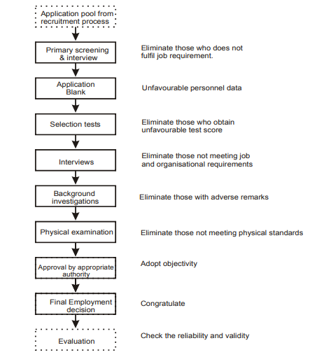The major factors which determine the steps involved in a selection process are as follows:

* Selection process depends on the number of candidates that are available for selection.
* Selection process depends on the sources of recruitment and the method that is adopted for making contact with the prospective candidates.
* Various steps involved in as selection process depend on the type of personnel to be selected

**Recruitment and Selection:**

**Interviewing:**

* **Interview:**
* An interview is a procedure designed to get information from a person and to assess his potential for the job he is being considered on the basis of oral responses by the applicant to oral inquiries by the interviewer.
* Interviewer does a formal in-depth conversation with the applicant, to evaluate his suitability. It is one of the most important tools in the selection process. This tool is used when interviewing skilled, technical, professional and even managerial employees. It involves two-way exchange of information.
* The interviewer learns about the applicant and the candidate learns about the employer

Types of interviews: Interviews can be classified in various ways according to:

* Degree of Structure
* Purpose of Interview
* Content of Interview

1. **Degree of Structure**

* Unstructured or non directive: in which you ask questions as they come to mind. There is no set format to follow.
* Structured or directive: in which the questions and acceptable responses are specified in advance. The responses are rated for appropriateness of content

1. **Purpose of Interview:**

* A selection interview is a type of interview designed to predict future job performance, on the basis of applicant’s responses to the oral questions asked to him.
* A stress interview is a special type of selection interview in which the applicant is made uncomfortable by series of awkward and rude questions. The aim of stress interview is supposedly to identify applicant’s low or high stress tolerance. In such an interview the applicant is made uncomfortable by throwing him on the defensive by series of frank and often discourteous questions by the interviewer

1. **Content of Interview:**

* The content of interview can be of a type in which individual’s ability to project a situation is tested. This is a situation type interview.
* In job-related interview, interviewer attempts to assess the applicant’s past behaviours for job related information, but most questions are not considered situational.
* In a behaviour interview a situation in described and candidates are asked how they behaved in the past in such a situation.
* While in situational interviews candidates are asked to describe how they would react to situation today or tomorrow.
* In the behavioural interview they are asked to describe how they did react to the situation in the past

**Human Resource Development(HRD):**

* Human resource development can be defined as a set of systematic and planned activities designed by an organisation to provide its members with the opportunities to learn necessary skills to meet current and future job demands.
* **Important characteristics of HRD**
* HRD is a system and HRD develops the competencies at all levels.
* HRD is continuous and planned development effort.
* The ultimate objective of HRD is to contribute to the professional well-being, motivation and pride of the employees
* Indicators of HRD at the organisational level
* HRD instruments/sub-systems/mechanisms, (e.g., HRD departments, appraisal systems, job-rotation, training, and development etc.)
* HRD processes, (e.g., role clarity, trust, openness, pro-action, collaboration, etc.)
* HRD outcomes (E.g. more competent people, work, etc.)
* Organisational outcomes (improved performance, profits, diversification, image productivity, etc.)

**Performance Appraisal:**

* Performance Appraisal is the systematic evaluation of the performance of employees and to understand the abilities of a person for further growth and development. Performance appraisal is generally done in systematic ways which areas follows:
  + The supervisors measure the pay of employees and compare it with targets and plans.
  + The supervisor analyses the factors behind work performances of employees.
  + The employers are in position to guide the employees for a better performance

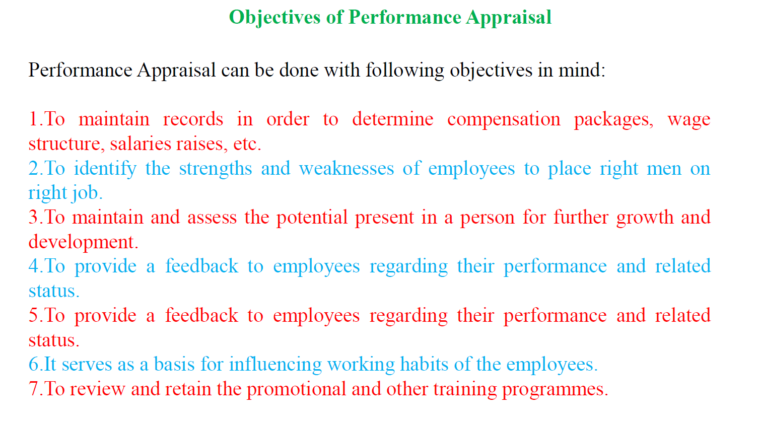

**Advantages of Performance Appraisal:**

* Promotion
* Compensation
* Employee's development
* Selection Validation
* Communication
* Motivation
* **Promotion:**
* Performance Appraisal helps the supervisors to chalk out the promotion programmes for efficient employees. In this regard, inefficient workers can be dismissed or demoted in case.
* **Compensation:**
* Performance Appraisal helps in chalking out compensation packages for employees.
* Merit rating is possible through performance appraisal.
* Performance Appraisal tries to give worth to a performance. Compensation packages which includes bonus, high salary rates, extra benefits, allowances and pre-requisites are dependent on performance appraisal. The criteria should be merit rather than seniority.
* **Employee’s Development:**
* The systematic procedure of performance appraisal helps the supervisors to frame training policies and programmes.
* It helps to analyse strengths and weaknesses of employees so that new jobs can be designed for efficient employees. It also helps in framing future development programmes.
* **Selection Validation:**
* Performance Appraisal helps the supervisors to understand the validity and importance of the selection procedure.
* The supervisors come to know the validity and thereby the strengths and weaknesses of selection procedure.
* Future changes in selection methods can be made in this regard.
* **Communication:**
* For an organization, effective communication between employees and employers is very important.
* Through performance appraisal, communication can be sought for in the following ways:
* Through performance appraisal, the employers can understand and accept skills of subordinates.
* The subordinates can also understand and create a trust and confidence in superiors.
* It also helps in maintaining cordial and congenial labour management relationship.
* It develops the spirit of work and boosts the morale of employees.
* **Motivation:**
* Performance appraisal serves as a motivation tool. Through evaluating performance of employees, a person’s efficiency can be determined if the targets are achieved.
* This very well motivates a person for better job and helps him to improve his performance in the future.
* **Communication:**
* For an organization, effective communication between employees and employers is very important.
* Through performance appraisal, communication can be sought for in the following ways:
* Through performance appraisal, the employers can understand and accept skills of subordinates.
* The subordinates can also understand and create a trust and confidence in superiors.
* It also helps in maintaining cordial and congenial labour management relationship.
* It develops the spirit of work and boosts the morale of employees.
* **Motivation:**
* Performance appraisal serves as a motivation tool. Through evaluating performance of employees, a person’s efficiency can be determined if the targets are achieved.
* This very well motivates a person for better job and helps him to improve his performance in the future.

**Employee Compensation:**

* Compensation or Remuneration is a systematic approach to provide monetary value to employees in exchange for work performed by them is called as compensation or remuneration.
* Compensation may achieve several purposes assisting in recruitment, job performance and job satisfaction.
* To attract well-qualified and competent personnel.
* To motivate them for higher levels of performance by making arrangement of incentive payments.
* To retain the present workforce by keeping their pay levels at the competitive levels.
* To raise the morale of workforce.
* To establish internal as well as external equity. Internal equity refers to payment of similar wages for similar work. External equity means payment of similar wages to similar jobs in comparable firms.
* To maintain the labour and administrative costs in line with the ability of the organization to pay.
* **External Factors:**
* Demand and supply of labour in the labour market.
* Labour union influence.
* Government policies like Minimum Wages Act, 1948, the Equal Remuneration Act 1976, etc.
* The prevailing rate of pay or comparable wage rates also influence the employee compensation.
* The present cost of living.
* The state of the economy (boom, recession, depression, etc.).
* Advancement of technology also influences the fixation of wage levels
* **Internal Factors:**
* These factors include the following:
* Ability of the organization to pay.
* The performance, experience and seniority of the employee.
* Requirements of the job such as physical and mental abilities.
* Job evaluation helps to establish satisfactory wage differentials.
* Organization’s strategy regarding employee compensation.
* The major components or constituents of employee
* compensation may include the following:
* Component # 1. Basic Wage:
* Component # 2. Dearness Allowance:
* Component # 3. Bonus:
* Component # 4. Allowances:

**Organizational Behaviour:**

* The behavioral management theory is often called the human relations movement because it addresses the human dimension of work.
* Behavioral theorists believed that a better understanding of human behavior at work, such as motivation, conflict, expectations, and group dynamics, improved productivity

**Importance of Organizational Behaviour:**

* + It helps in explaining the interpersonal relationships employees share with each other as well as with their higher and lower subordinates.
  + The prediction of individual behavior can be explained.
  + It balances the cordial relationship in an enterprise by maintaining effective communication.
  + It assists in marketing.
  + It helps managers to encourage their sub-ordinates.
  + Any change within the organization can be made easier.
  + It helps in predicting human behavior & their application to achieve organizational goals.
  + It helps in making the organization more effective.
* Motivation is inspiring the subordinates to contribute with zeal and enthusiasm towards organizational goals.
* Performance of an employee depends on two factors, ability to work and willingness to work. Mathematically
* Performance = Ability × willingness
* Motivation is enhancing the willingness to work which improves the performance

**Importance of Motivation:**

* Motivated employee are more quality oriented.
* Highly motivated employees are more productive as compared to other employees.
* It helps in achieving three behavior dimension of human resource namely
  + Candidates must be attracted not only to join but also remain in the firm.
  + Employees must perform task in a dependable manner.
  + Employees should be creative, spontaneous and innovative at work
* **Positive Motivation**
* Makes the people induce to do their work in the best possible manner and improve their performance.
* Rewards and facilities may be financial or non financial.
* **Negative Motivation**
* Aims at controlling the negative efforts of the workers and so inducing them to work positively in the interest of organization.
* Punishments reprimands fear of loss of job are some of the methods used.

**Maslow’s theory of motivation:**

* Humanistic psychologist, proposed a hierarchy of five needs:
* Physiological, Safety, Social, Esteem and Self-Actualization (The full realization of one’s potential" and of one's "true self.“)
* He proposed that man was a wanting animal whose behaviour was calculated to serve his most pressing needs.
* A need can be described as a physiological or psychological deficiency that a person is motivated to satisfy.
* Maslow further proposed that man’s need could be placed in a hierarchy of needs
* The study shows that a man has various needs and their order can be determined.
* Diagram, text

  Description automatically generatedThe moment the first need of man is satisfied he starts thinking of the second need, and then follows his worry about the third need and the sequence continues till all the needs are satisfied.

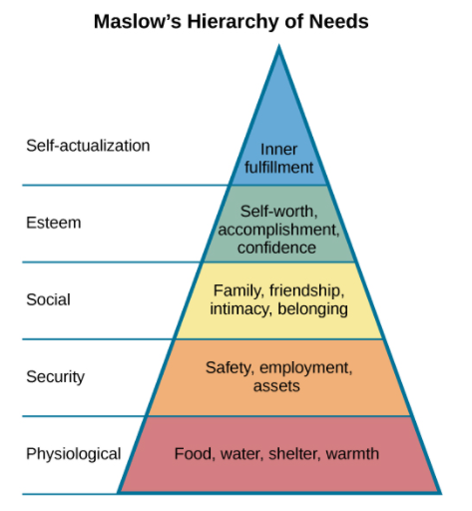

* **Physiological Needs**
* This category includes those needs which a man needs to satisfy first of all in order to remain alive. It includes food to eat, house to live in, clothes to wear and sleep for rest.
* **Safety Needs**
* After having satisfied the physical needs a man thinks of his safety. Safety needs mean physical, economic and psychological safety. Physical safety means saving him from accidents, diseases and other unforeseen situations.
* Economic safety means security of employment and making provision for old age. Psychological safety means maintaining his prestige
* **Social Needs**
* Man is a social being and wants to live in society with honour.
* It is, therefore, necessary that he should have friends and relatives with whom he can share his joys and sorrows
* **Esteem and Status Needs**
* They are called ego needs of man. It means everybody wants to get a high status which may
* increase his power and authority.
* **Self Actualization Needs**
* Last of all man tries to satisfy his self actualization need. It means that a man should become what he is capable of.
* For example- a musician wants to be proficient in the art of music, an artist wants to gain proficiency in creating works of art and similarly, a poet wants to be an expert in the art of writing poems.

**Herzberg's two factor Theory:**

* Herzberg’s Motivation Theory model, or Two Factor Theory, argues that there are two factors that an organization can adjust to influence motivation in the workplace.
* These factors are:
* Motivators: Which can encourage employees to work harder.
* Hygiene factors: These won’t encourage employees to work harder but they will cause them to become unmotivated if they are not present.

**Motivational factors**- According to Herzberg, the hygiene factors cannot be regarded as motivators. The motivational factors yield positive satisfaction.

* These factors are inherent to work. These factors motivate the employees for a superior performance. These factors are called satisfiers.
* These are factors involved in performing the job. Employees find these factors intrinsically rewarding. The motivators symbolized the psychological needs that were perceived as an additional benefit.

**Motivational factors include:**

* **Recognition** - The employees should be praised and recognized for their accomplishments by the managers.
* **Sense of achievement** - The employees must have a sense of achievement. This depends on the job. There must be a fruit of some sort in the job.
* **Growth and promotional opportunities** - There must be growth and advancement opportunities in an organization to motivate the employees to perform well
* **Responsibility** - The employees must hold themselves responsible for the work. The managers should give them ownership of the work. They should minimize control but retain accountability.
* **Meaningfulness of the work** - The work itself should be meaningful, interesting and challenging for the employee to perform and to get motivated

**Hygiene factors:**

* Hygiene factors are those job factors which are essential for existence of motivation at workplace. These do not lead to positive satisfaction for long-term.
* But if these factors are absent / if these factors are non-existant at workplace, then they lead to dissatisfaction
* Hygiene factors are also called as dissatisfiers or maintenance factors as they are required to avoid dissatisfaction.

**Hygiene factors include**:

* **Pay** - The pay or salary structure should be appropriate and reasonable. It must be equal and competitive to those in the same industry in the same domain.
* **Company Policies and administrative policies** - The company policies should not be too rigid.
* They should be fair and clear. It should include flexible working hours, dress code, breaks, vacation, etc.
* **Fringe benefits** - The employees should be offered health care plans (mediclaim), benefits for the family members, employee help programmes, etc
* **Physical Working conditions** - The working conditions should be safe, clean and hygienic.
* The work equipments should be updated and well-maintained.
* **Status** - The employees’ status within the organization should be familiar and retained.
* **Interpersonal relations** - The relationship of the employees with his peers, superiors and subordinates should be appropriate and acceptable. There should be no conflict or humiliation element present.
* **Job Security** - The organization must provide job security to the employees

**Limitations of Two Factor Theory:**

* The two-factor theory overlooks situational variables.
* Herzberg assumed a correlation between satisfaction and productivity. But the research conducted by Herzberg stressed upon satisfaction and ignored productivity.
* The theory’s reliability is uncertain. Analysis has to be made by the raters. The raters may spoil the findings by analyzing same response in different manner.
* No comprehensive measure of satisfaction was used. An employee may find his job acceptable despite the fact that he may hate/object part of his job
* The two-factor theory is not free from bias as it is based on the natural reaction of employees when they are enquired the sources of satisfaction and dissatisfaction at work.
* They will blame dissatisfaction on the external factors such as salary structure, company policies and peer relationship.
* Also, the employees will give credit to themselves for the satisfaction factor at work

**Difference between Human Relation and Behavioral Sciences Approach:**



**Stress and Conflict:**

* Stress is a feeling of being under too much mental or emotional pressure, and a feeling that you are unable to cope.
* Most people experience stressful situations at some point and our bodies generate stress hormones (which trigger our internal ‘fight or flight’ response) to help us deal with them
* **Conflict:**
* Conflict at a basic level involves a serious disagreement or argument.
* There can be conflict at home between family members or between countries at an international level.
* Conflict can be either informal or formal.
* Informal conflict may involve a minor disagreement between two people.
* Formal conflict could result in a claim brought against an organisation in an employment tribunal

**Management by Objectives:**

* Management by Objectives (MBO) is a strategic approach to enhance the performance of an organization.
* It is a process where the goals of the organization are defined and conveyed by the management to the members of the organization with the intention to achieve each objective

**Benefits of Management by Objectives:**

* Management by objectives helps employees appreciate their on-the-job roles and responsibilities.
* The Key Result Areas (KRAs) planned are specific to each employee, depending on their interest, educational qualification, and specialization.
* The MBO approach usually results in better teamwork and communication.
* It provides the employees with a clear understanding of what is expected of them. The supervisors set goals for every member of the team, and every employee is provided with a list of unique tasks.
* Every employee is assigned unique goals. Hence, each employee feels indispensable to the organization and eventually develops a sense of loyalty to the organization.
* Managers help ensure that subordinates’ goals are related to the objectives of the organization.

**Limitations of Management by Objectives:**

* Management by objectives often ignores the organization’s existing ethos and working conditions.
* More emphasis is given on goals and targets. The managers put constant pressure on the employees to accomplish their goals and forget about the use of MBO for involvement, willingness to contribute, and growth of management.
* The managers sometimes over-emphasize the target setting, as compared to operational issues, as a generator of success.

**Job Enrichment:**

* Job enrichment is a way to motivate employees by giving them increased responsibility and variety in their jobs.
* Many employers traditionally believed that money was the only true motivating factor for employees and that if you wanted to get more work out of employees, offering them more money was the only way to do it.
* While that may be true for a small group of people, the majority of workers today like to work and to be appreciated for the work they do.
* Job enrichment— allowing the employees to have more control in planning their work and deciding how the work should be accomplished—is one way to tap into the natural desire most employees have to do a good job, to be appreciated for their contributions to the company, and to feel more a part of the company team.

**Job Rotation:**

* Job Rotation is a management approach where employees are shifted between two or more assignments or jobs at regular intervals of time in order to expose them to all verticals of an organization.
* It is a pre-planned approach with an objective to test the employee skills and competencies in order to place him or her at the right place.
* In addition to it, it reduces the monotony of the job and gives them a wider experience and helps them gain more insights